Assignment – 1

# **Power BI Final Screenshot**

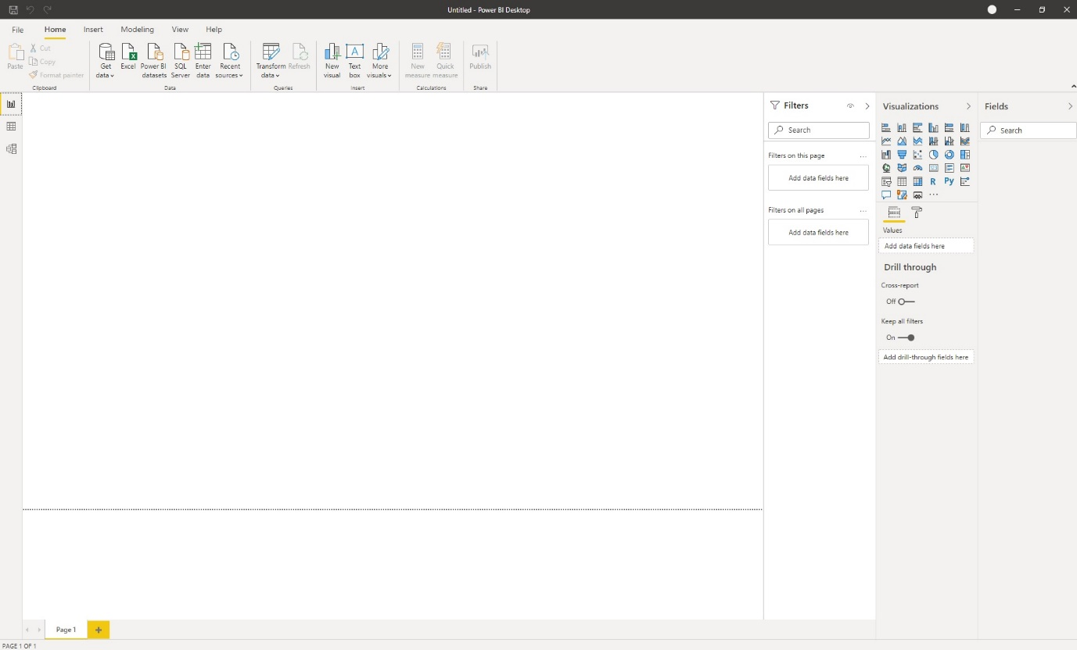

# **Power BI Views**

## **Report View**



## **Data View**

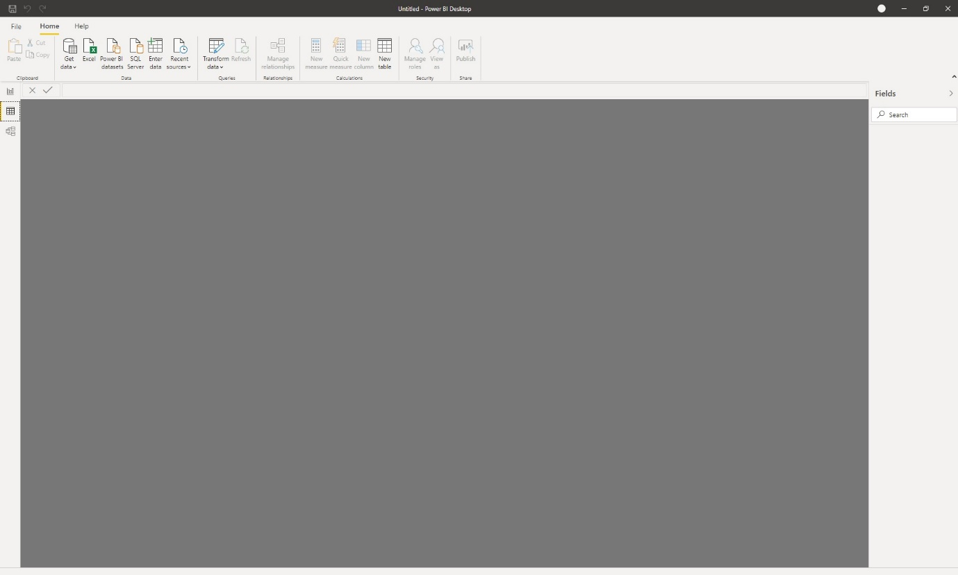

## **Model View**

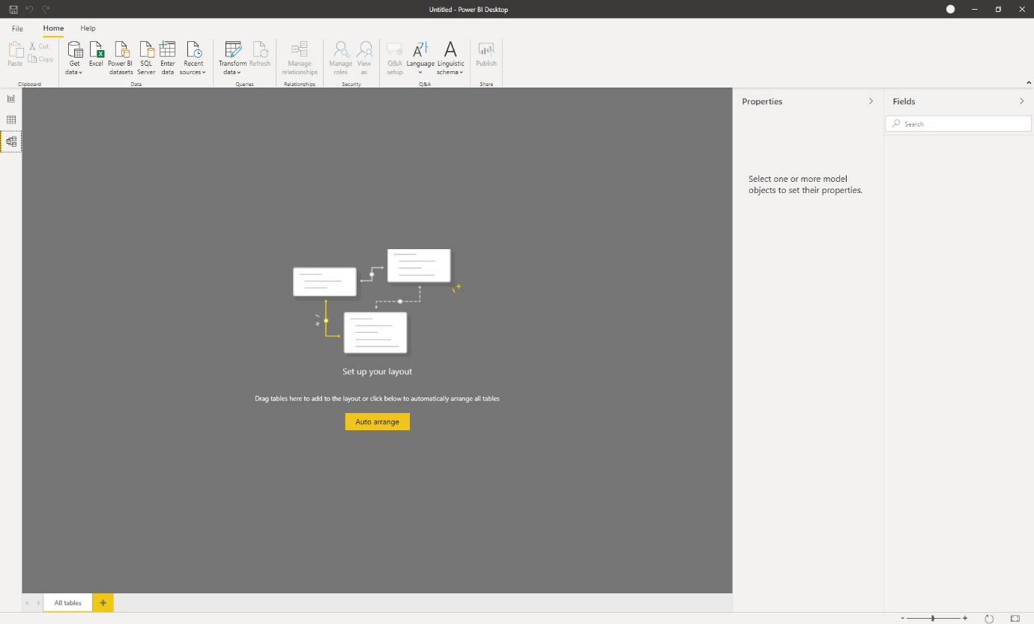

## **Power Query Editor**

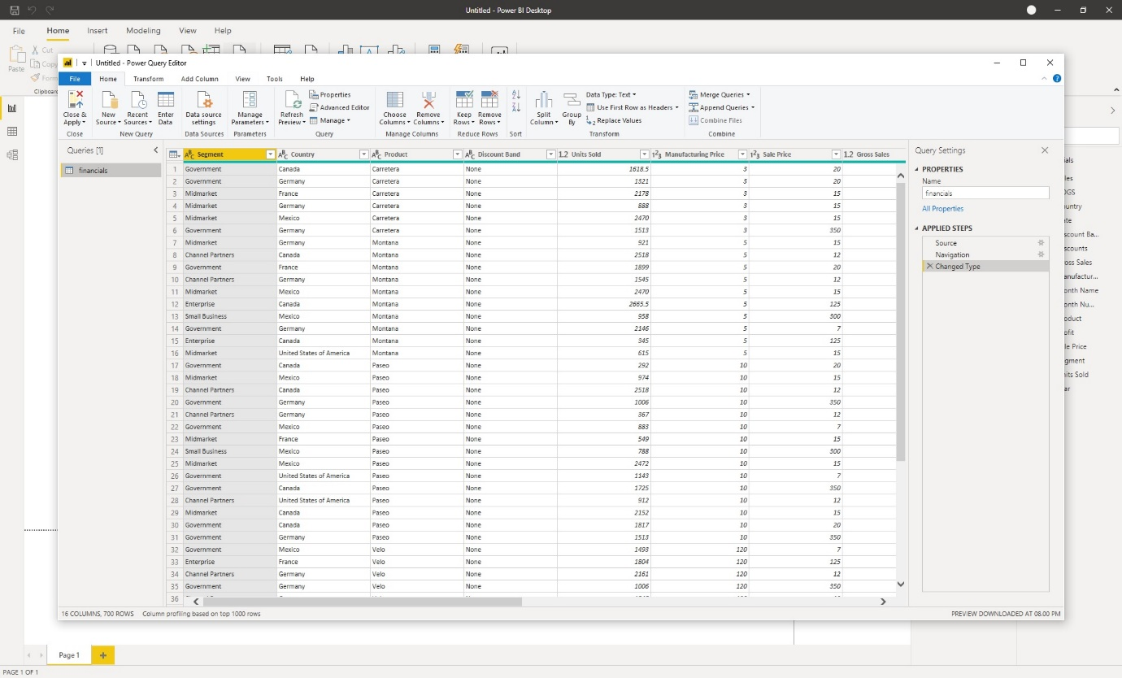

## **Advance Editor**

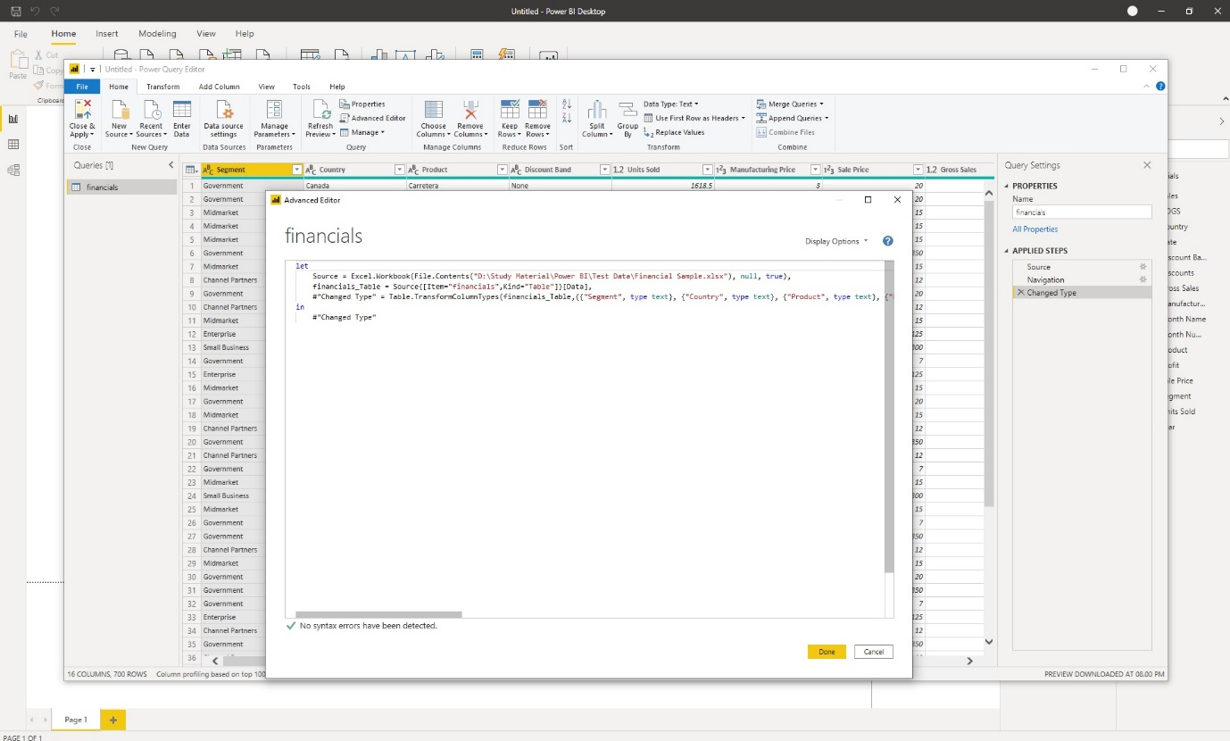

# **Power BI Pricing**

**Power BI Desktop* – Free**

